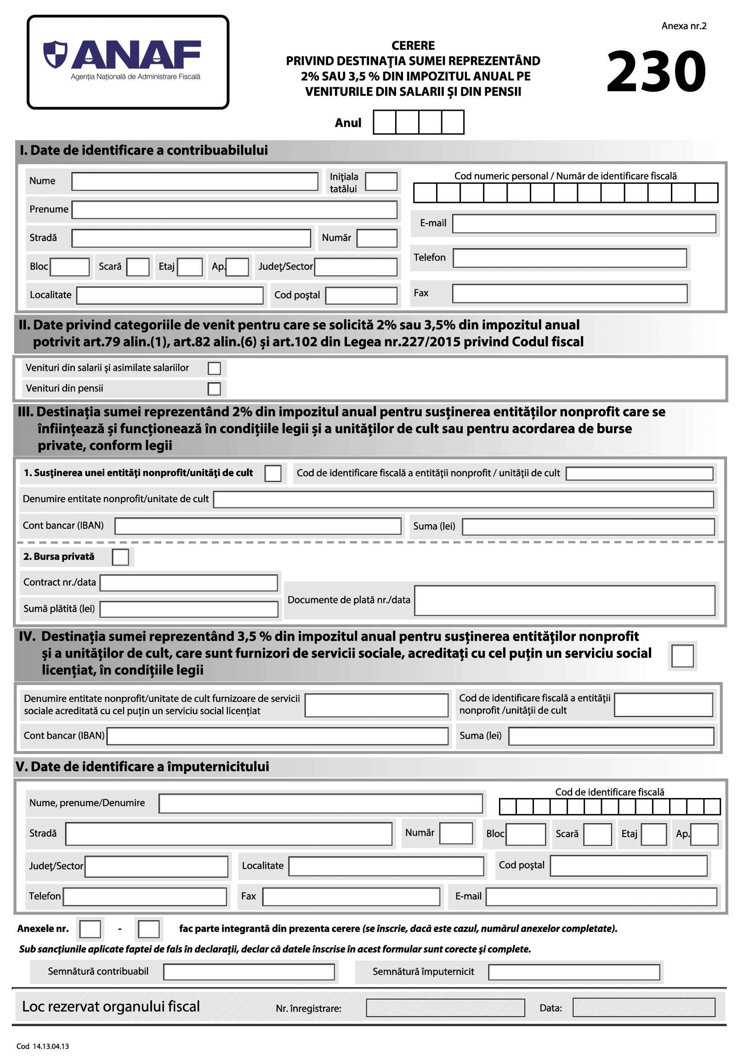

X

**Asociatia MAHAVIRA ANANDA**

**RO77 RNCB 0072 1702 0450 0001**

|  |  |  |  |  |  |  |  |  |  |  |  |  |  |  |  |  |  |  |  |  |  |  |
| --- | --- | --- | --- | --- | --- | --- | --- | --- | --- | --- | --- | --- | --- | --- | --- | --- | --- | --- | --- | --- | --- | --- |
|  |  |  | |  | |  | |  | |  | |  | |  |  | |  | |  | |  | |
|  |  | |  | |  | |  | |  | |  | |  | | |  | |  | |  | |  | |  |

|  |  |  |  |  |  |  |  |  |  |  |  |  |
| --- | --- | --- | --- | --- | --- | --- | --- | --- | --- | --- | --- | --- |
|  |  |  |  |  |  |  |  |  |  |  |  |  |
|  |  |  |  |  |  |  |  |  |  |  |  |  |

**26708613**

2 0 2 2